Speaker Tutorial: How to Present a Session at GIDS Live
Tip: Please use the latest version of Chrome browser for the best experience. If you face issues with screensharing on Chrome, please switch to Firefox. The experience is poor on Edge and Safari.
There are two ways to present a session at GIDS Live.
- Present your talk LIVE to the audience and respond to questions in the text chat and Q&A on-camera during your session. More details in STEP 6 below.
- Pre-record your talk in high-definition video (720p) and upload it to YouTube as an unlisted video. Be present LIVE in your session room to respond to questions via text chat and Q&A. More details in STEP 7 below. If you decide to pre-record your talk, please send me the video file (.mp4 format) well in advance (latest by 20th April 2021).
Regardless of the option you choose, please follow the steps below to present your session at GIDS Live.
STEP 1: Navigate to the GIDS Live 2021 venue on Hopin: https://hopin.com/events/gids-live-2021 and click Log in

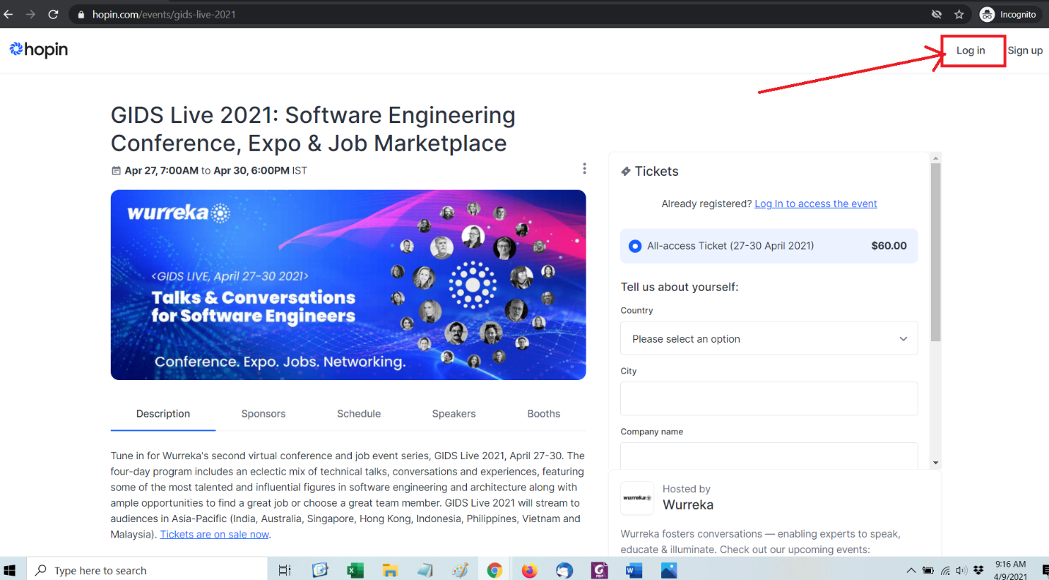

STEP 2: Log in to your Hopin account using the email ID and password you used to register your speaker ticket. If you forgot your password, you can ask for a reset on the same page.

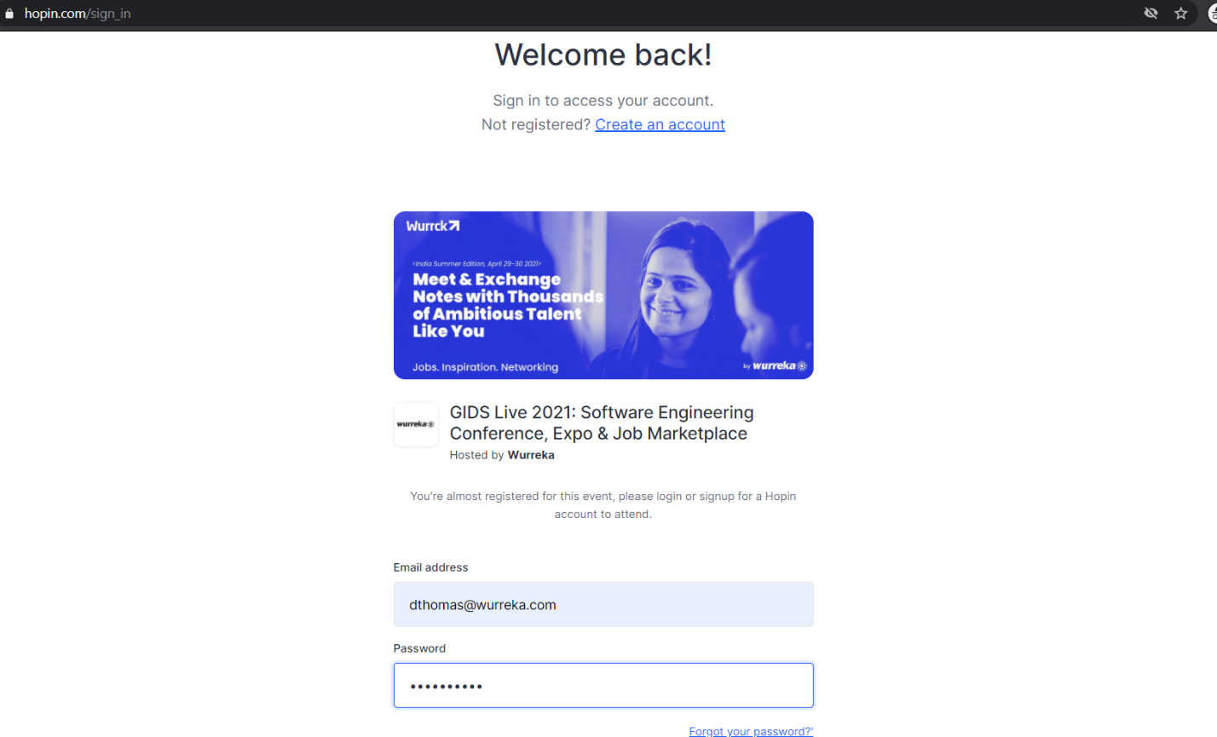

STEP 3: Navigate to the GIDS Live 2021 Reception. The event starts on Tuesday, 27th April at 1:30 AM GMT (convert to your time zone). You will be able to access the event’s Reception only 5 minutes prior to start of the event.
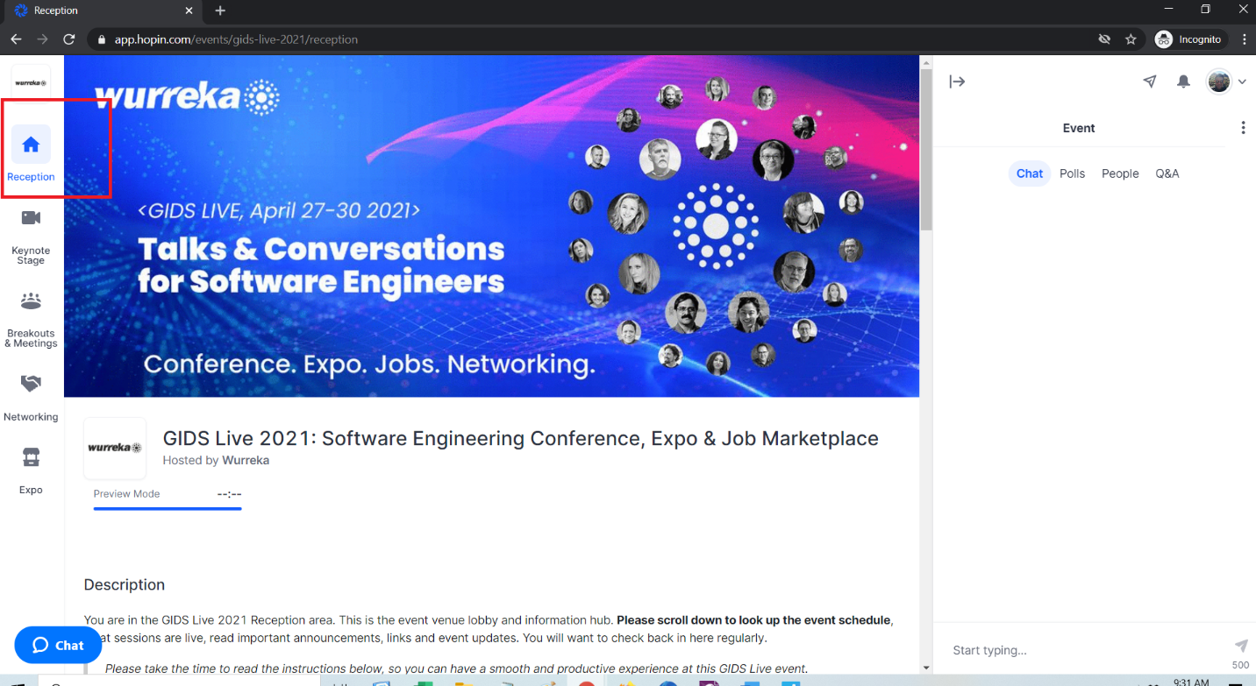

STEP 4: Click on Breakouts & Meetings to navigate to the area where your session room is hosted. Find your session room by searching for a keyword from your session title, or scrolling through the list, and click on it.

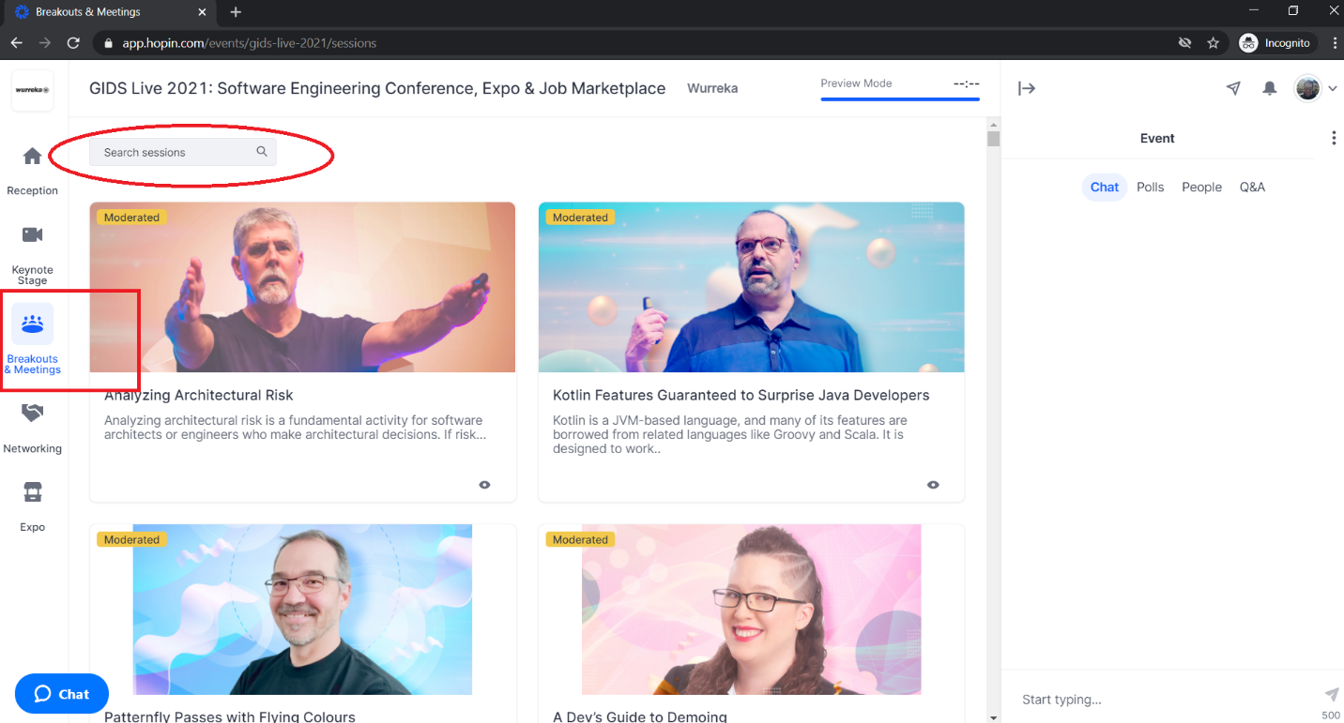
STEP 5: Click Share Audio and Video and ensure you Allow Hopin access to your camera and microphone — people will be able to see and hear you in the session.

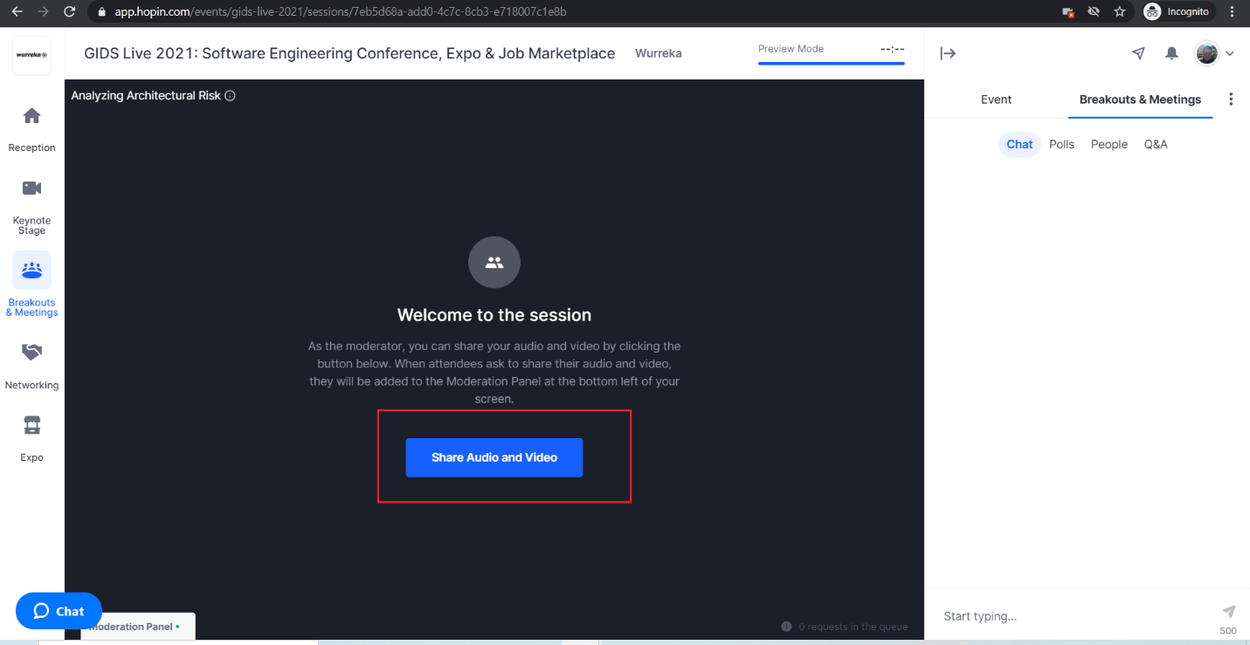

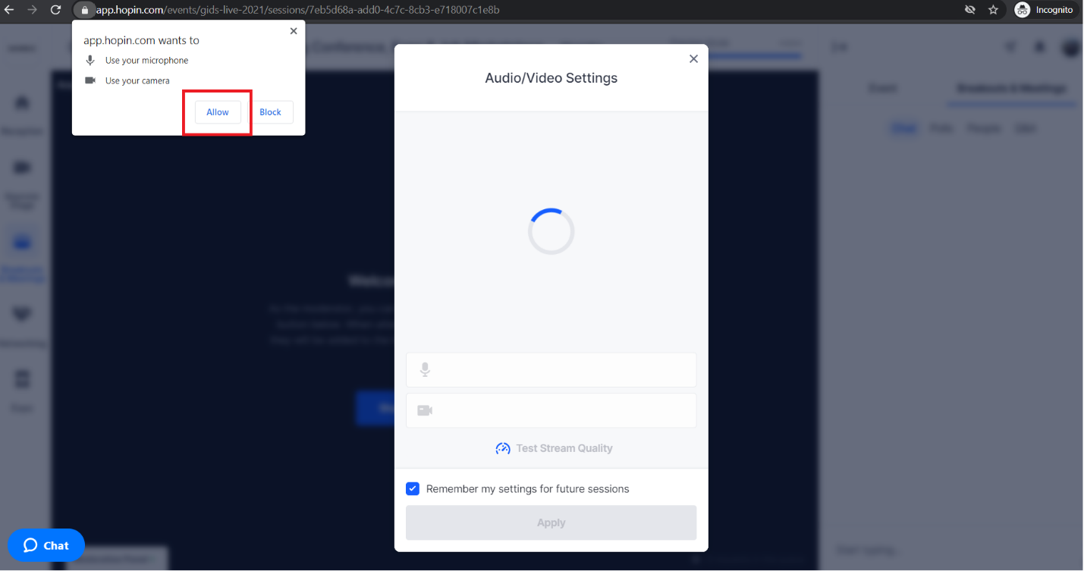

At the top of a session, you’ll notice the number of people speaking/max number allowed and the number of people watching the Session.
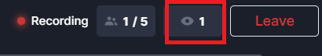
STEP 5: Once you are on screen, you will have the following Speaker controls at the bottom centre of the Session:
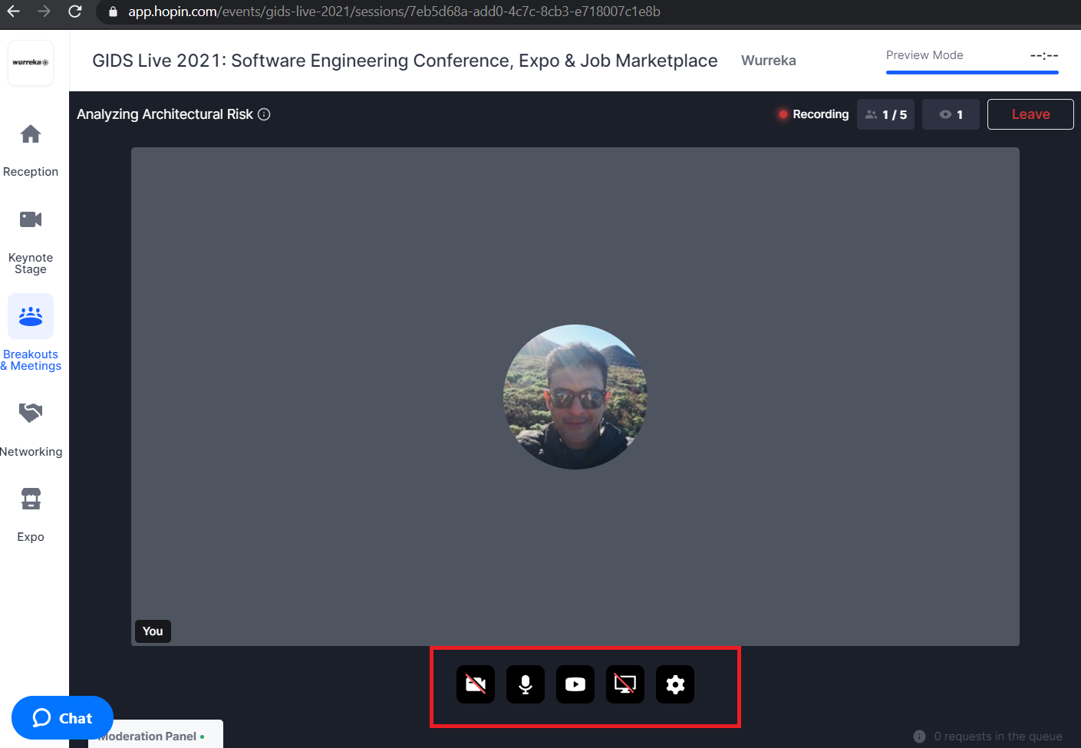

- Camera. Toggles your webcam on and off.
- Microphone. Toggles your microphone on and off.
- YouTube URL Input: please ignore this control
- Screen share. Opens a screen-share menu.
- Settings. Opens the hardware selection menu for you to choose the camera and microphone for this Session.
Plus, you can click on Leave at the top right corner to leave the Session at any time.
STEP 6: To present your session LIVE to the GIDS audience, you can share you:
- Entire Screen: this is a good option if you’d like to toggle between your code editor and slides.
- Application Window: Share an application such as a Powerpoint on Windows or Keynote on Mac
- a Chrome tab with sound on. Just make sure the sound starts playing before you share the screen.
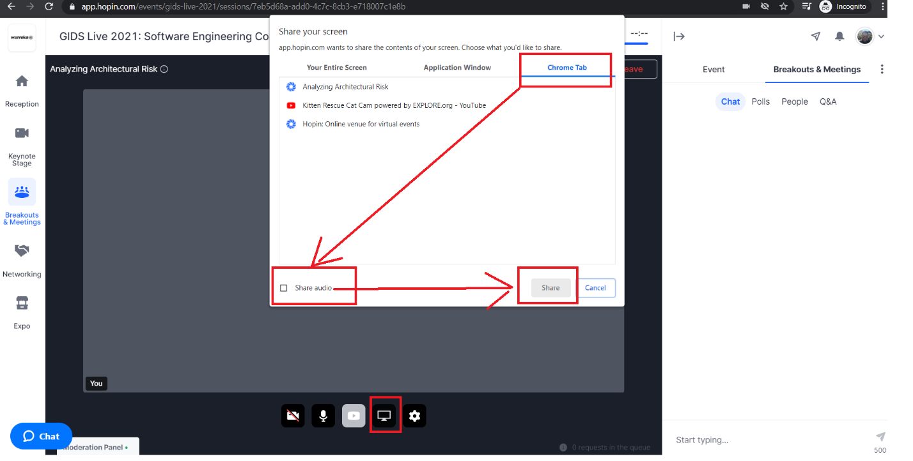

- Click Screen sharing icon at the bottom of the page
- Switch to Chrome Tab on the popup window and choose the required browser tab
- Check the Share audio box
- Click Share to start sharing
E.g. Sharing a Google Slides presentation or playing a video in a browser tab with sound can be supported on the latest version of Google Chrome browser.
Note: Firefox browser doesn’t support sharing a tab with Sound yet.
STEP 7: To present your pre-recorded session to the GIDS audience, follow these steps:
- Open your unlisted YouTube video on a Chrome Tab
- On the speaker controls at the bottom centre of your screen, toggle both your webcam and microphone off
- Share a Chrome tab with sound on and select the chrome tab playing your pre-recorded YouTube video (see screenshot above). Just make sure the sound starts playing before you share the screen.
- Toggle your webcam on and off once again. This will ensure attendees only see your pre-recorded video without your camera feed taking up their screen space.
STEP 8: Interacting with Attendees at your Session
Each session has its own group chat, separate from the event-wide chat. Participants at your session will interact with you via text chat using the Session chat.
Note: Participants at your session can also request to appear on-camera. Requests will appear as notifications on the Moderation Panel of your screen (bottom left). We recommend you ignore these requests and continue to interact with participants via the Session chat and Q&A.
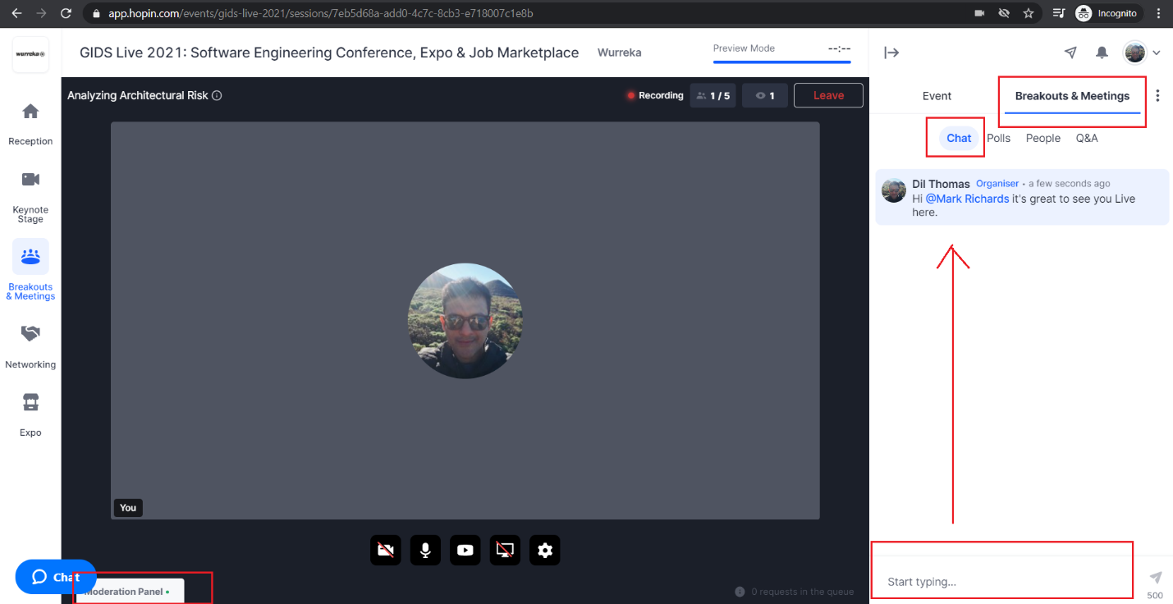

The Q&A feature also provides a great way for your attendees to ask questions and engage during your event. You can also filter questions by latest or most popular.
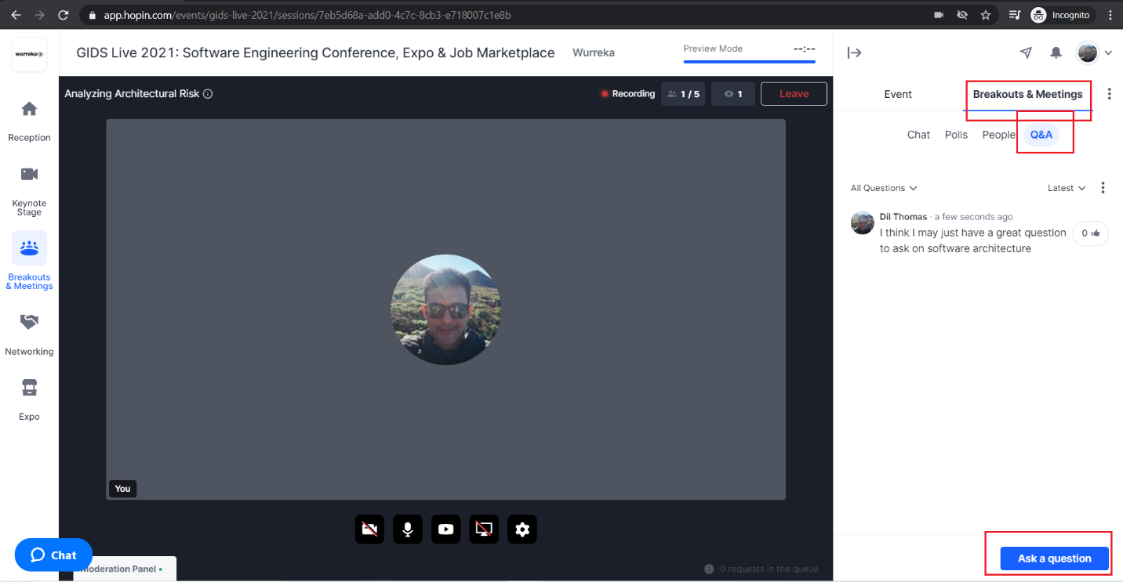

STEP 9 (Optional): Creating a Poll
You can also Create a Poll specific to your session. This is a simple one-liner poll with multiple options. The poll can be created either during your session or in advance of your session.
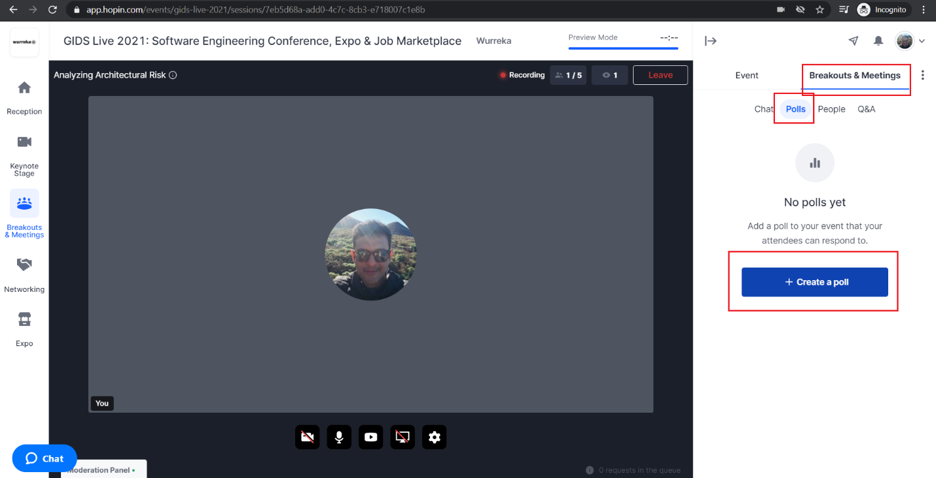

To create a poll in advance of your session, use the unique private URL to navigate to your session room (can be found in the description of the Google Calendar invite (see below) I have sent you) at the live event.
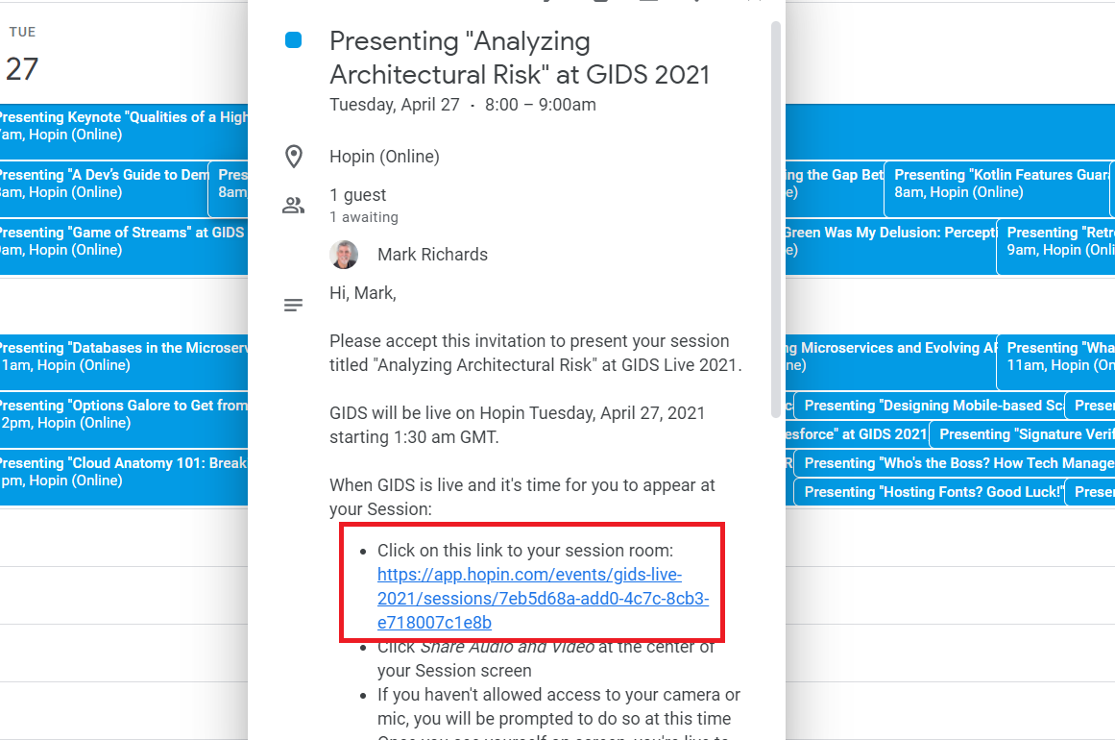

Important Notes (please read)
- To view your exact time slot (and duration of your talk), please look up the event schedule: https://wurreka.com/ict/virtual-conference/gids-2021/schedule or the live event schedule on Hopin on the day: https://hopin.com/events/gids-live-2021#schedule. My Google calendar invitation to you will also trigger a notification.
- Please arrive in your session room at the live event at least 15-20 minutes ahead of the start time of your talk.
- When you enter your session room, you will see a brief biography posted by either me or my colleague Usha Karen introducing you to participants on the Session Chat.
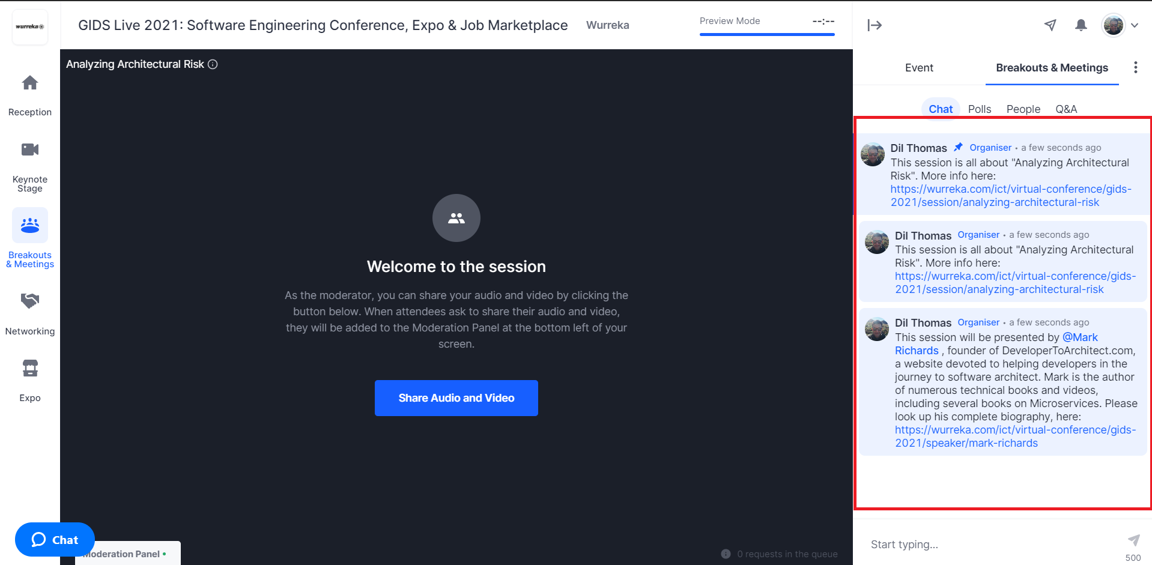

- Attendees will be able to enter your session room only 5 minutes prior to your talk. You can watch the counter on the top right of your screen to see how many attendees are in the room. They will see the introductory messages in the Session Chat.
- You may please get started with your session sharp on time as per the schedule.
- Sessions are of either 25 mins or 50 mins duration. This includes time for Q&A. Since there are back to back sessions on the schedule, as a mark of respect for the next speaker, please time your session to wrap up within the duration allotted on the event schedule. Hopin does not have a timer functionality, so please plan for one.
- For any questions and/or support you may need before or on the day of the event, please reach out to me on email <Dil Thomas dthomas@wurreka.com> or iMessage or send a WhatsApp to my cellphone +91 98804 56560.

